Scooter Sharing System user manual

Hi, welcome to the campus scooter sharing system ! Our system provides borrow and return services to provide faster on-campus travel, meanwhile, we also provide management and monitoring services for QM manager. Here we introduce our system in two modules.

Please run the ScooterSystem.java first in the main folder.

You can see the picture (Figure A.1), This is our welcome interface. Different users can choose the corresponding entrances to enter, but It is worth noting that if you use our system as an user, you must get an administrator's account opening permission. So let's first enter the administrator interface to find out how the administrators manage the system.

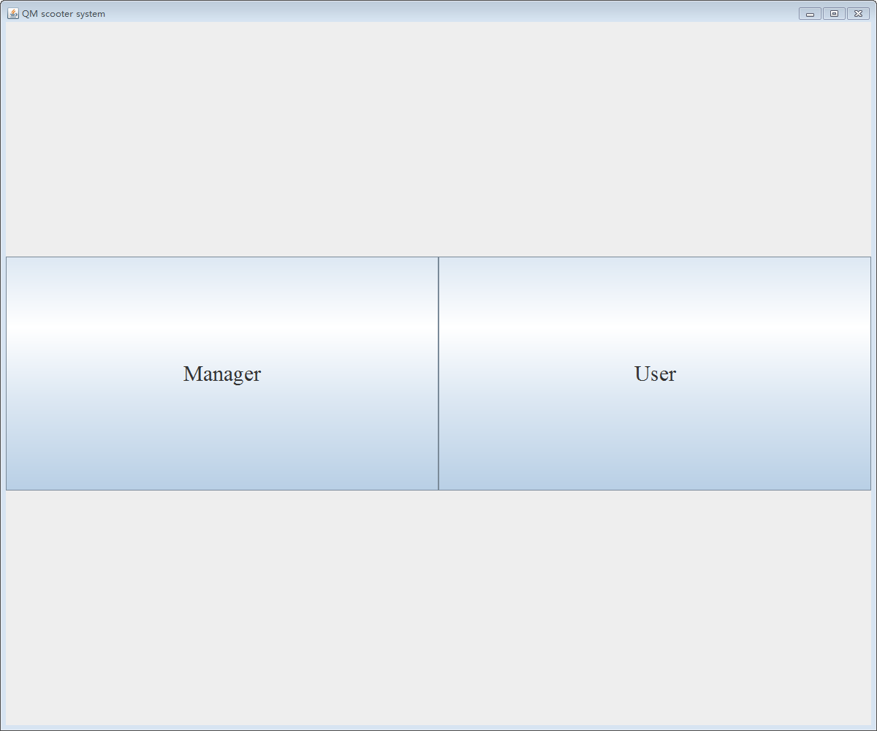
Figure A.1

A. Manager
a. If you are a scooter manager, you can help users register. The registration processes include:
Click the button “Manager”-> click the Register->input the ID/Full Name/Email Add.

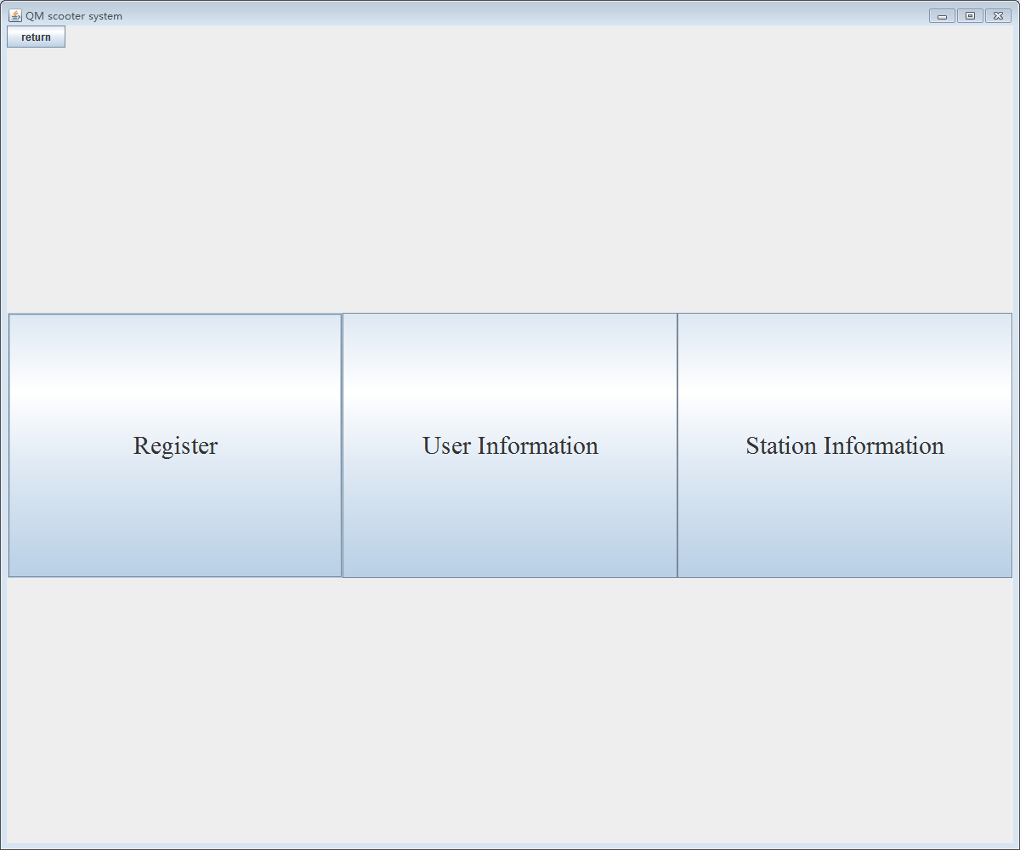
Figure A.2

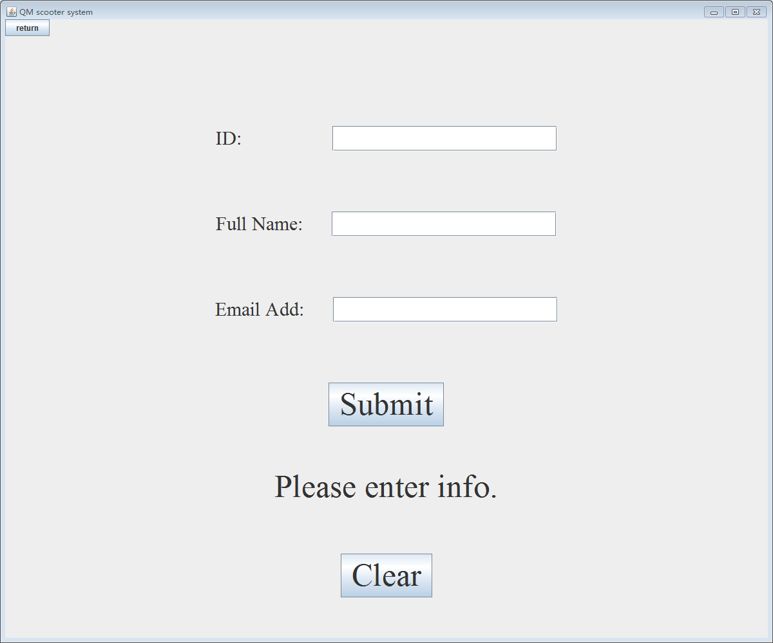
Figure A.3

If you enter the wrong info that doesn’t comply with the format, you can not register successfully and there will be a hint below the panel. You can click the button ‘Clear’ to clear all information you have typed in.
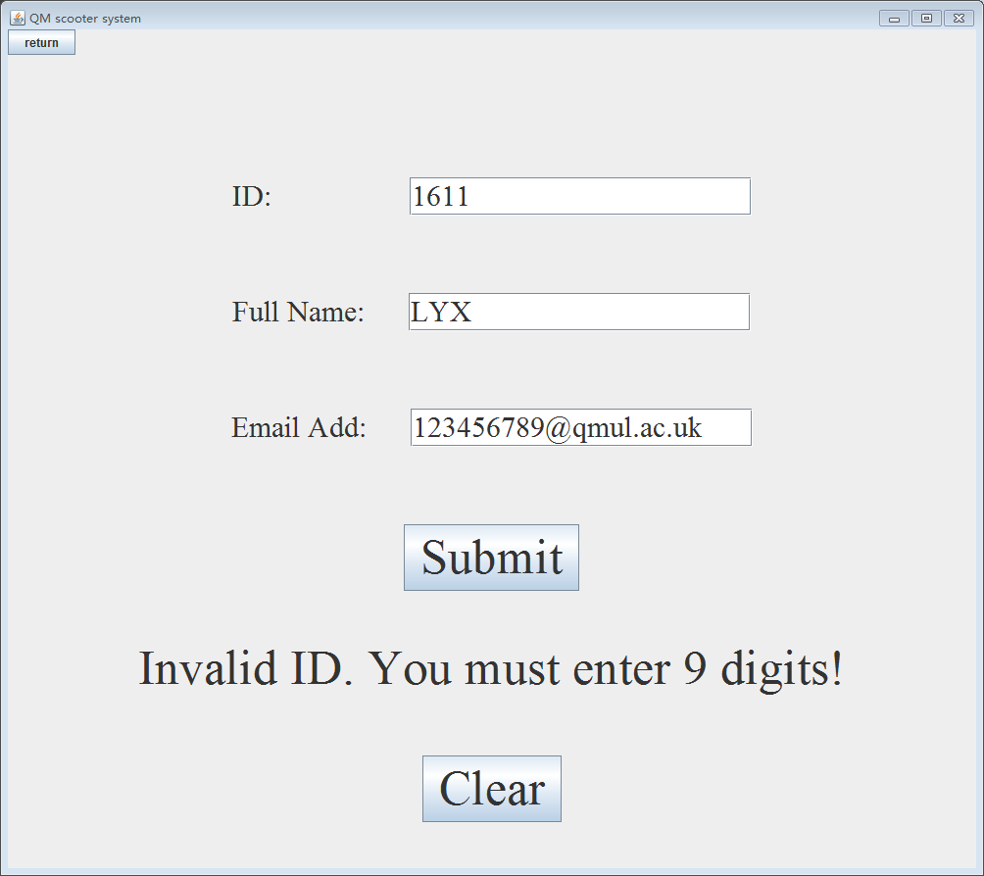
Figure A.4
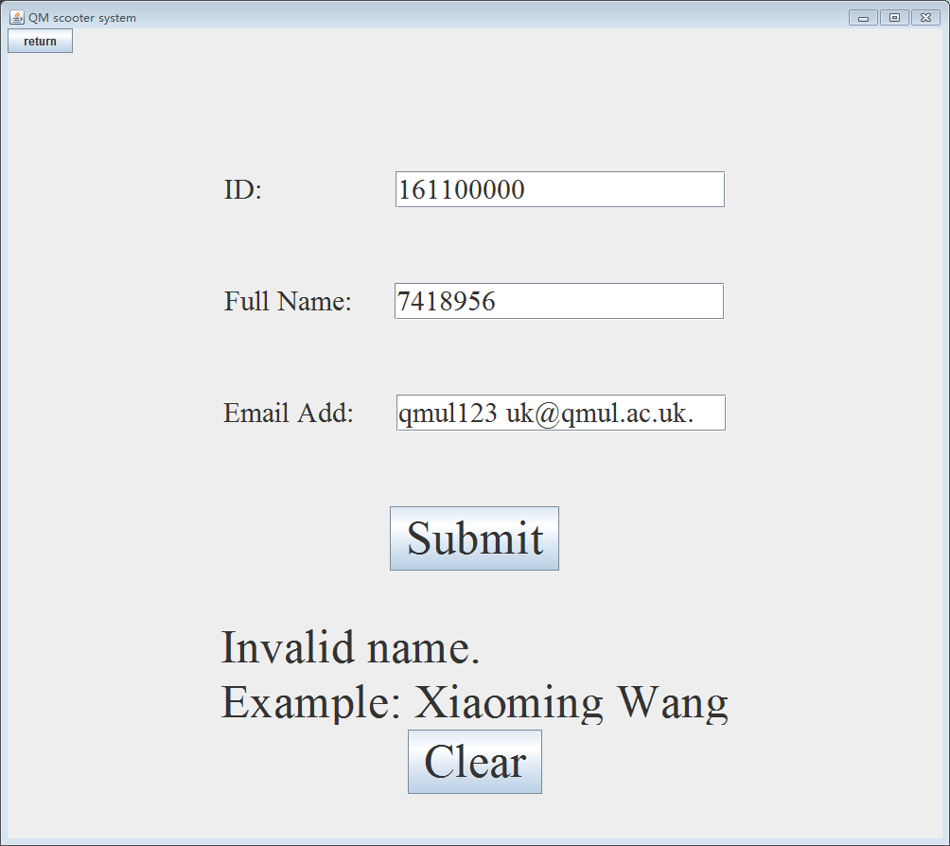
Figure A.5

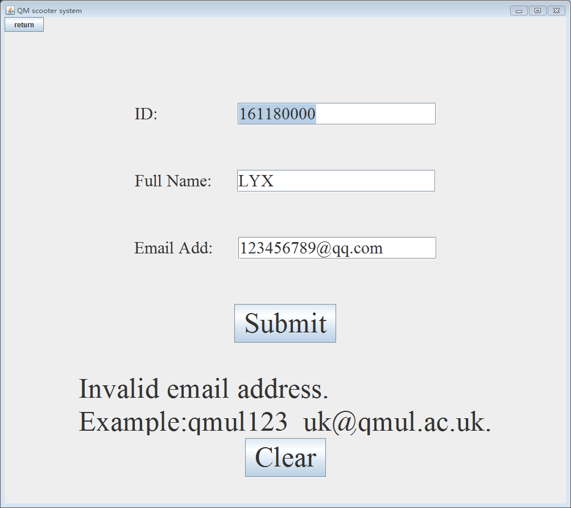
Figure A.6
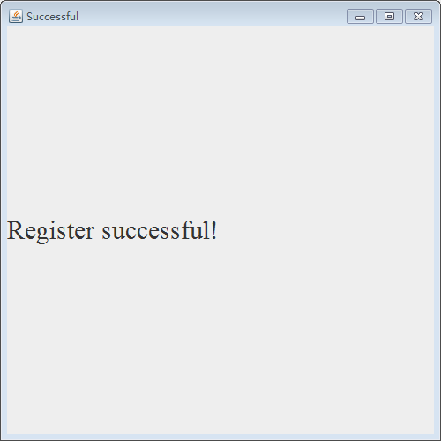
Figure A.7
b. As a manager, you are able to check the usage of each user at any time and monitor the status of each docking station. In total there are 3 docking station A, B and C around campus and each station has 5 scooters and 8 slots.
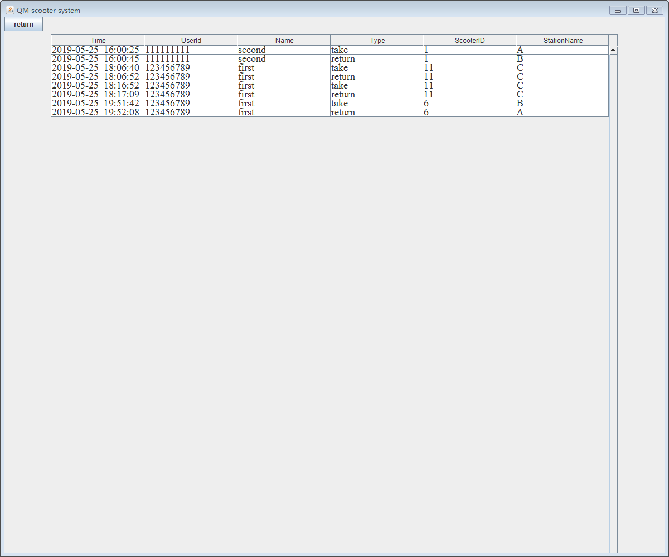
Figure A.8
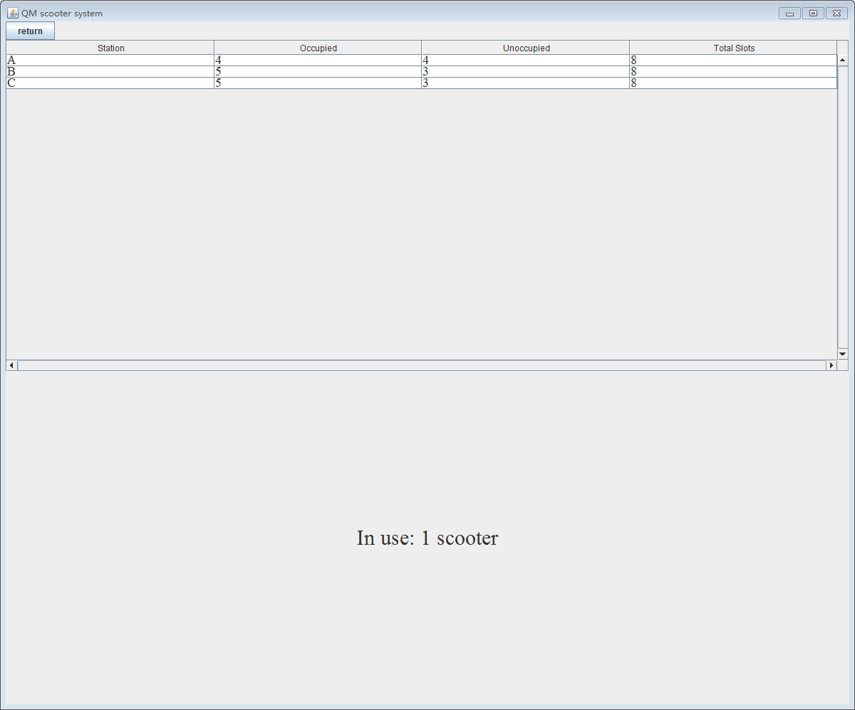
Figure A.9

B. User
If you are a scooter user, you must first contact to the manager to register, then click ‘User’ to choose the nearest station and log in to use scooter.
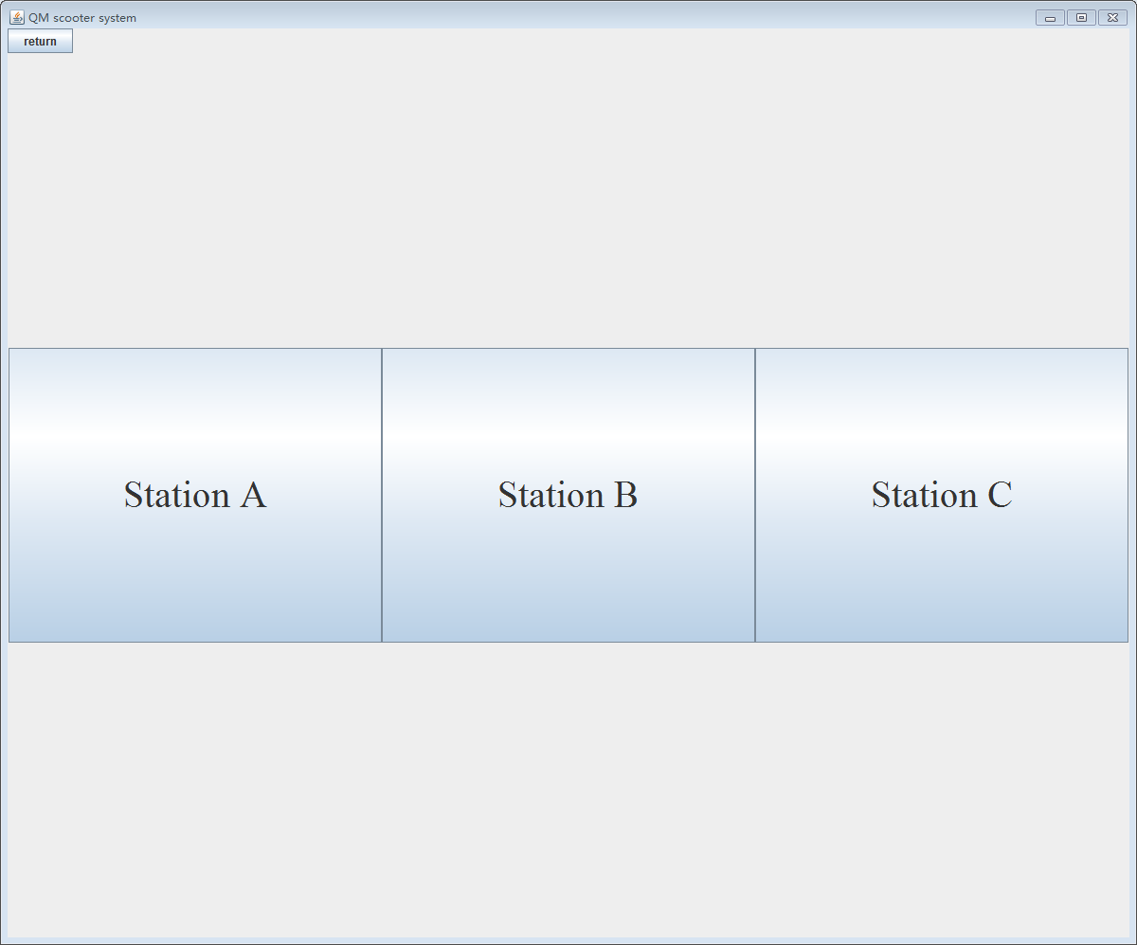
Figure B.1
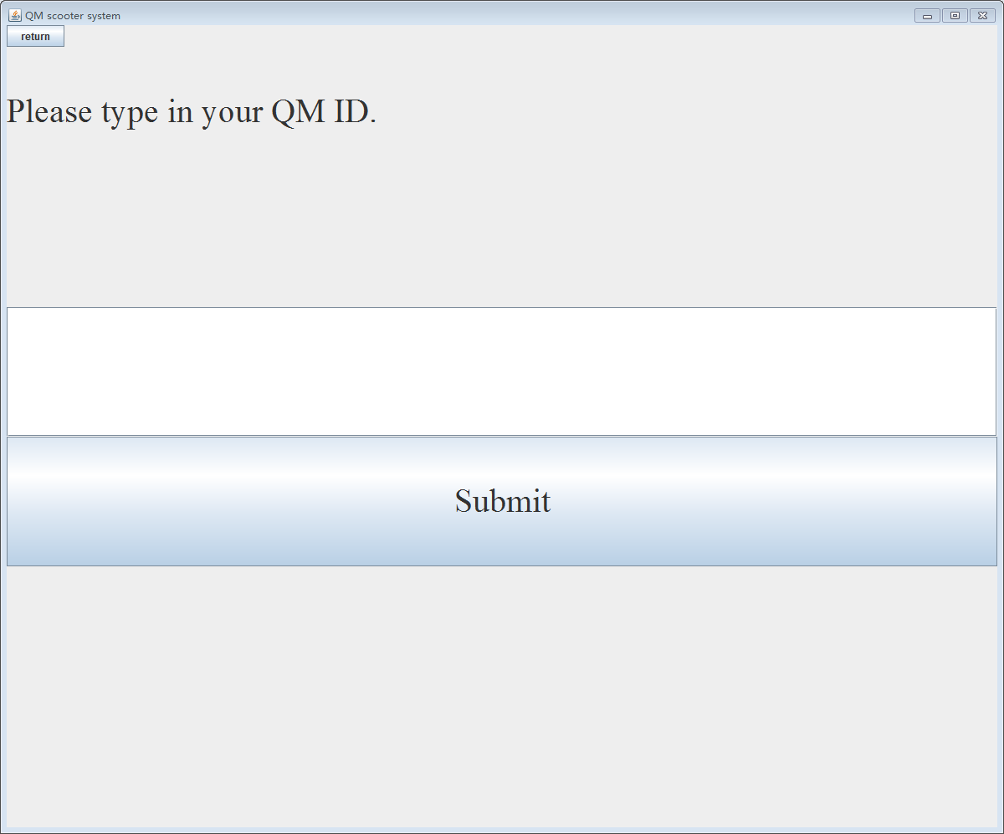
Figure B.2
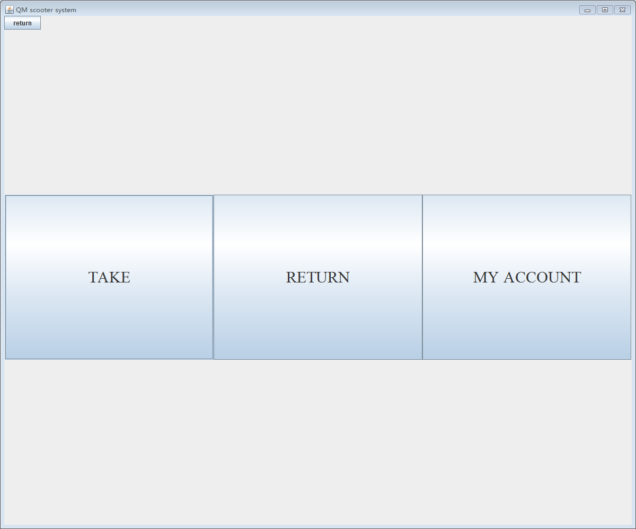
Figure B.3
- TAKE
Click ‘TAKE’ and ‘Help me pick one’, our system will choose a scooter for you and the red light at the slot will be flashing to inform you.

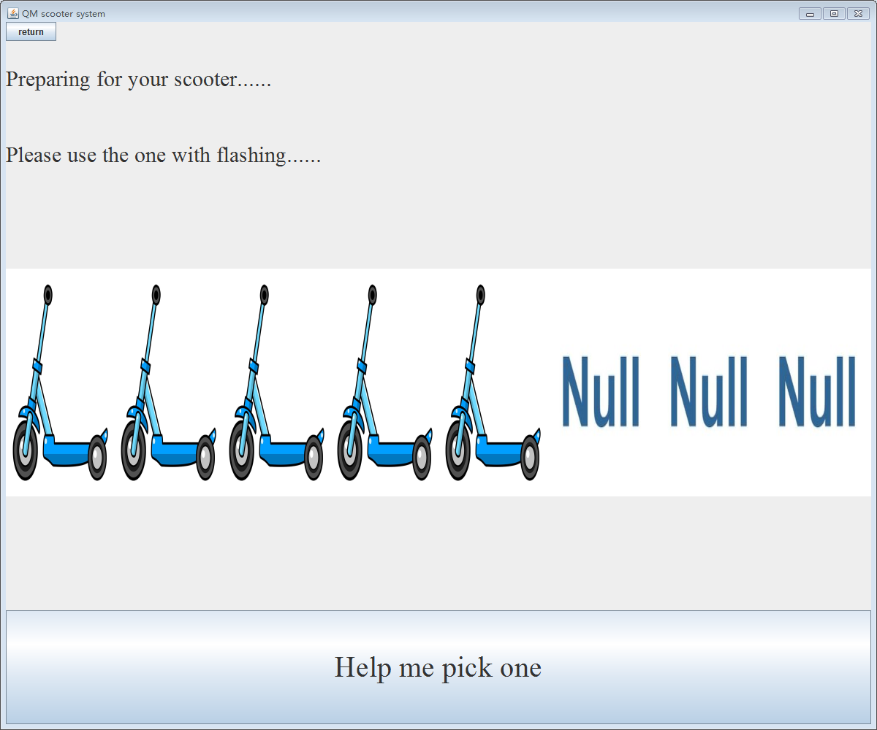
Figure B.4

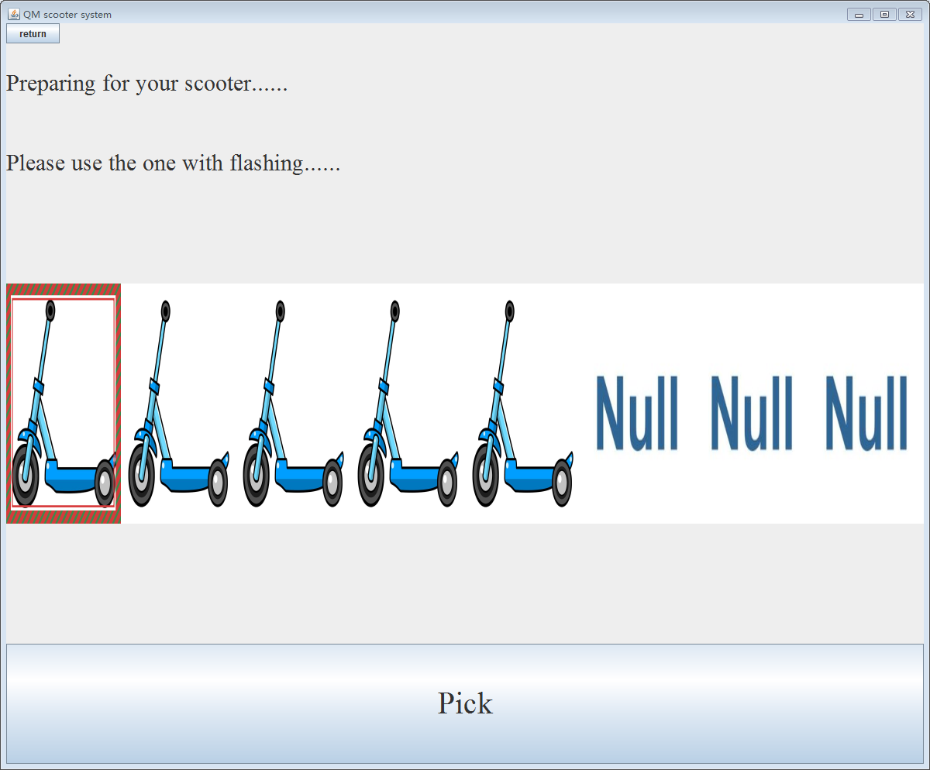
Figure B.5

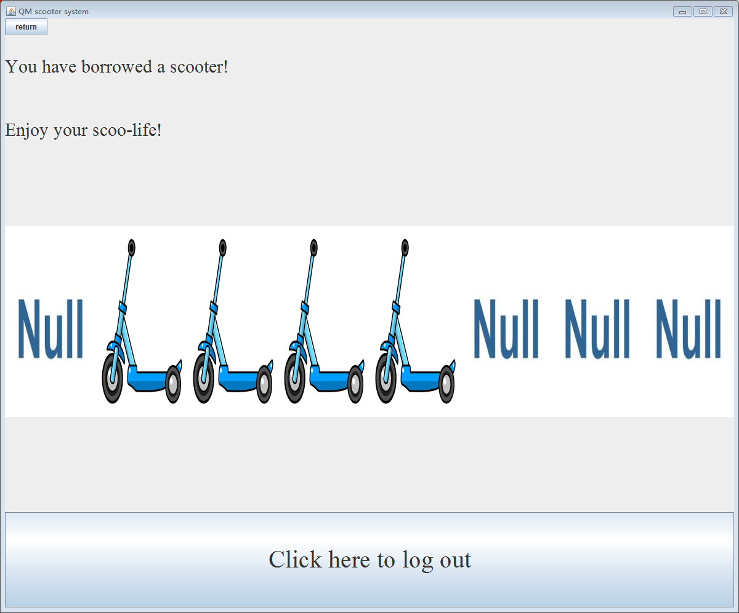
Figure B.6

If you do not take the scooter within 1 minute, the scooter will be locked to the slot automatically.
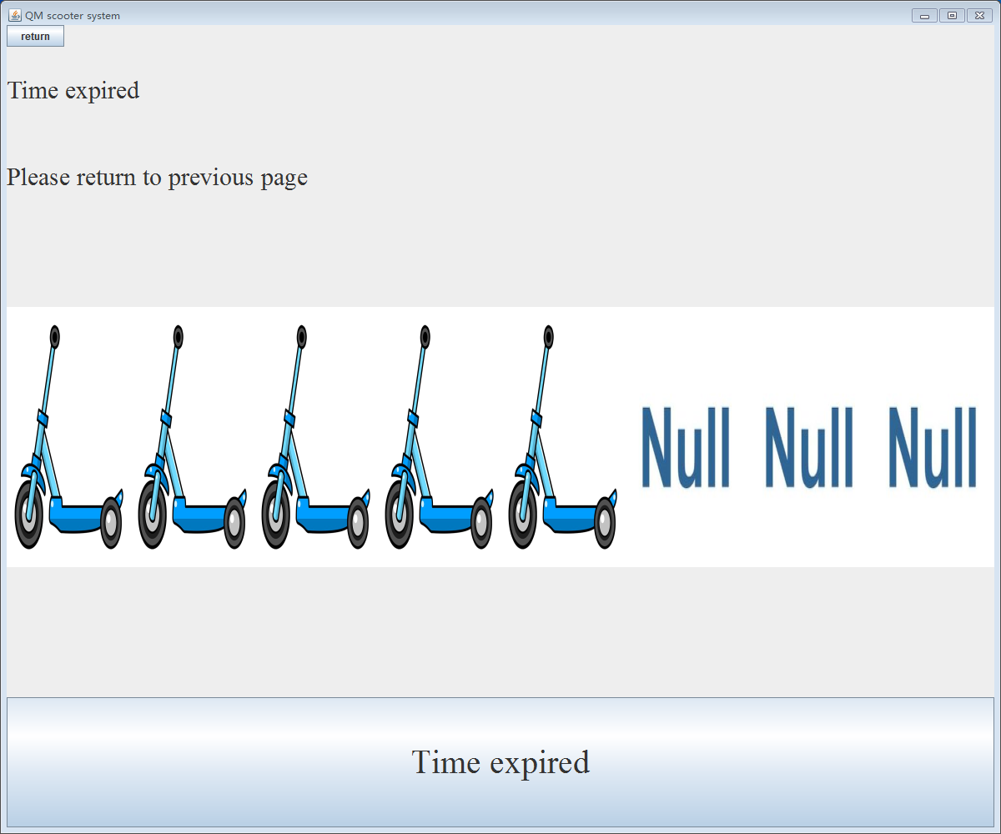
Figure B.7
- RETURN
Click ‘RETURN’ and ‘Help me pick an empty slot’, our system will make one empty slot ready and the light will flash. Also, If you do not return the scooter within 1 minute, the light will stop flash and you are unable to put the scooter in.
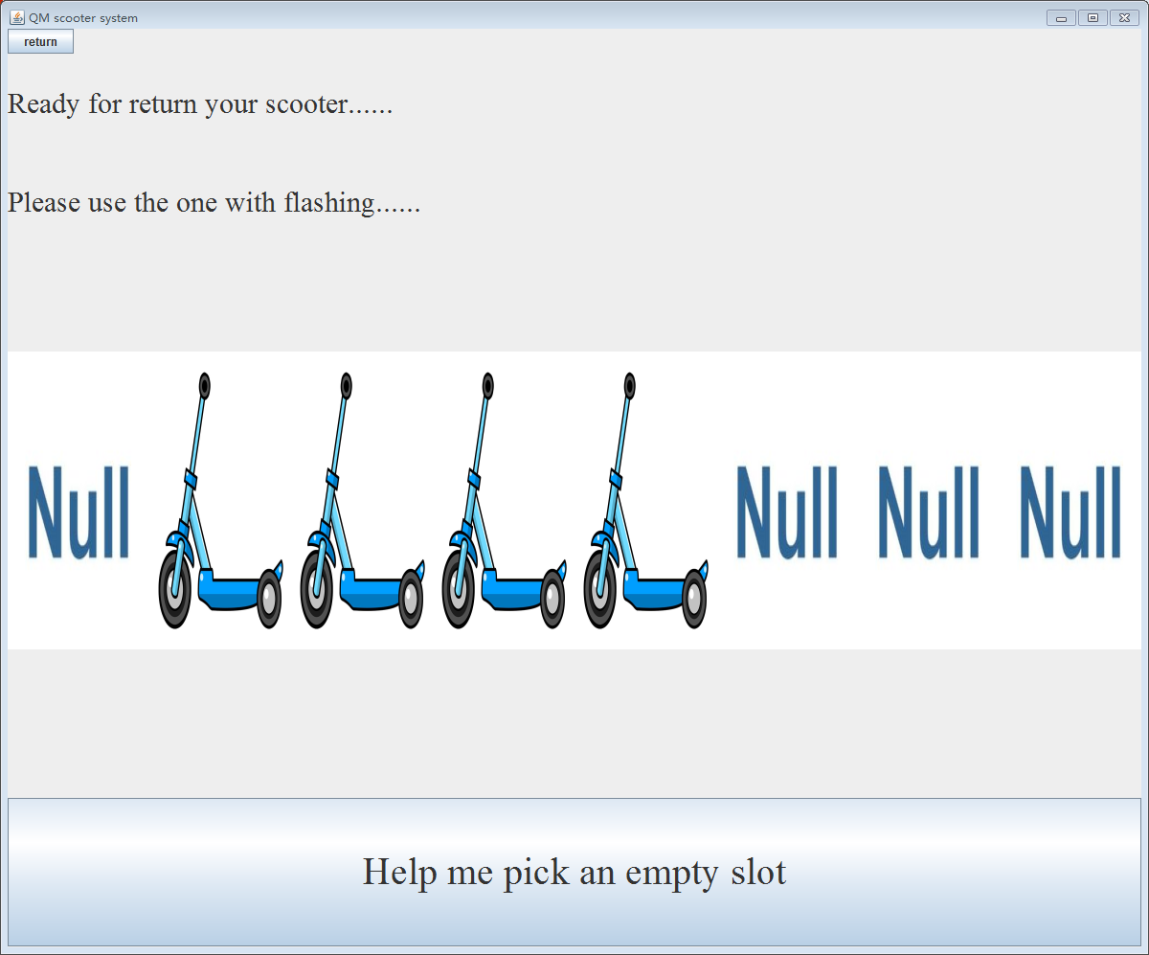
Figure B.8
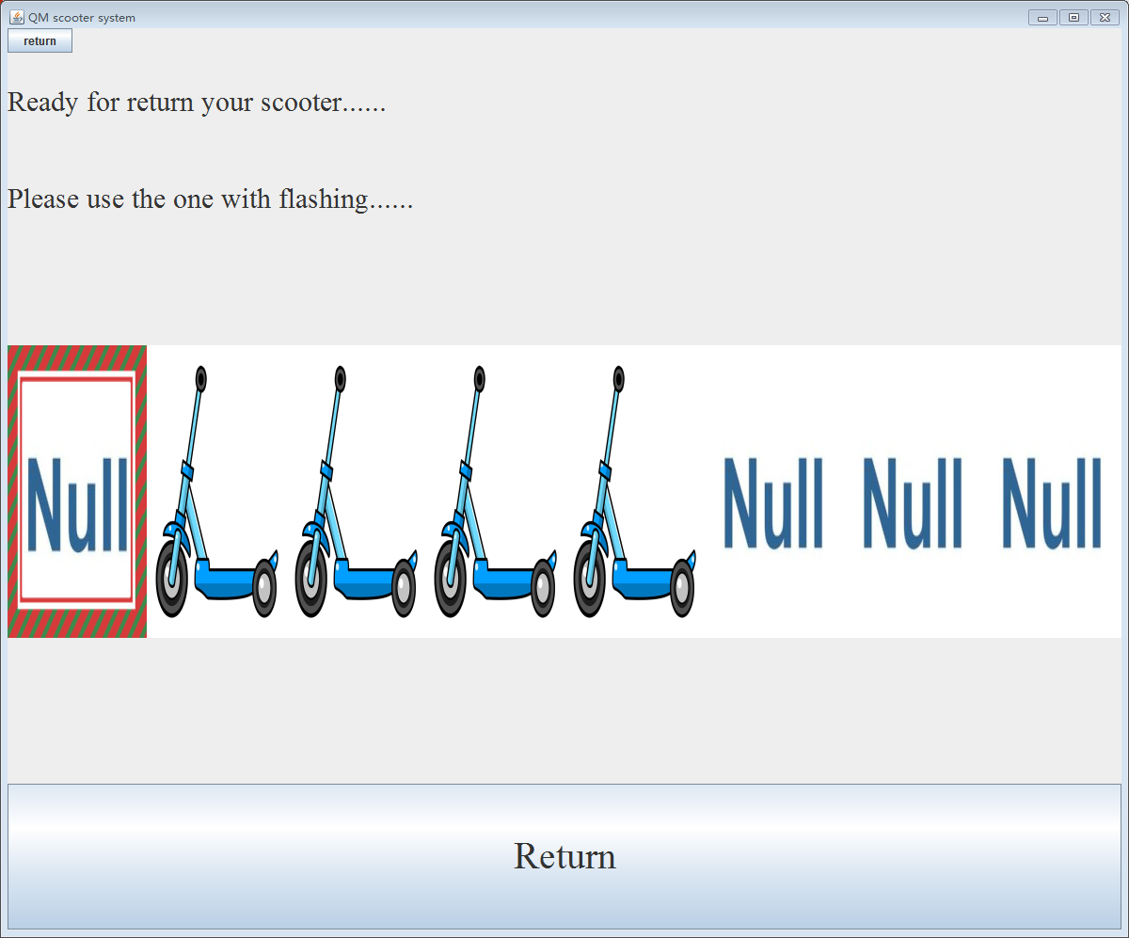
Figure B.9
- MY ACCOUNT
It is free to use the scooter however 1) each time the user must return a scooter within 30 minutes. 2) the total usage must not exceed 2 hours a day. Or a fine of ￡100 should be issued by click ‘Pay My Fine’ before the next time you use our scooter.
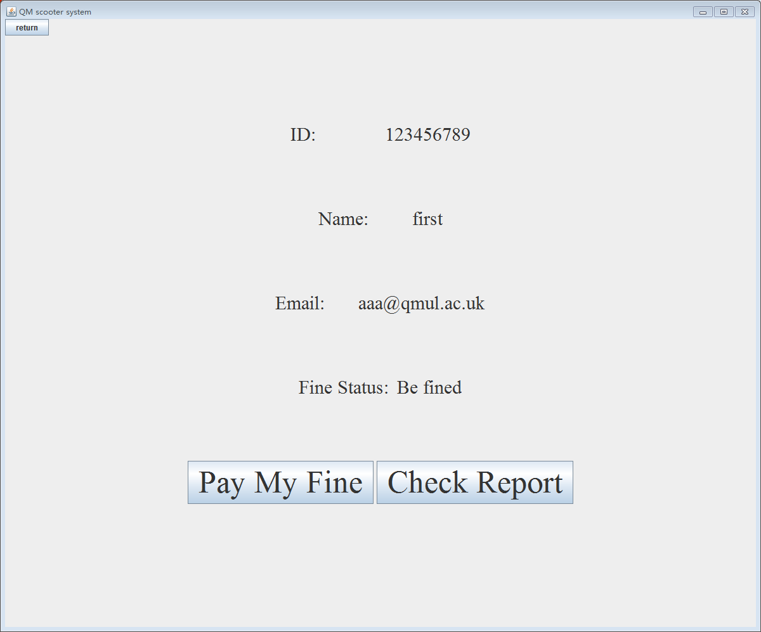
Figure B.10

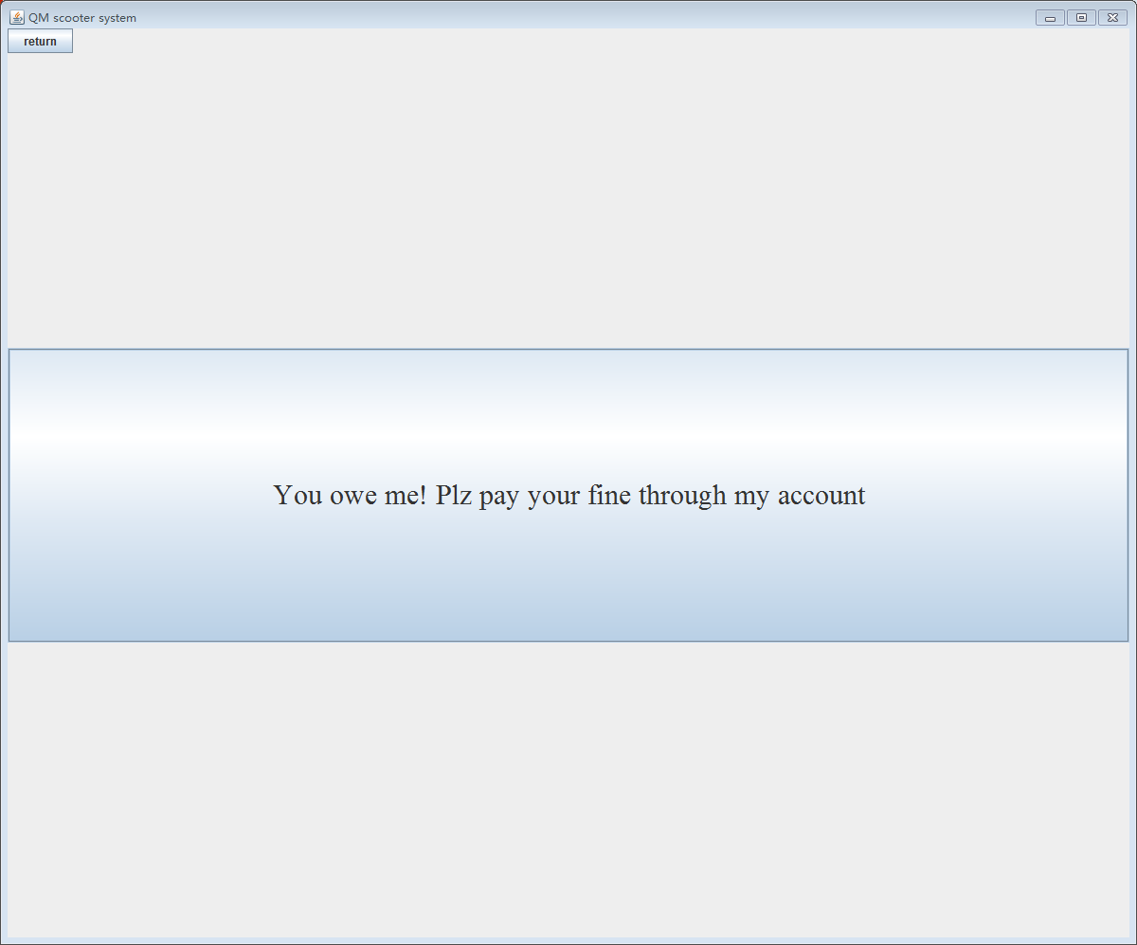
Figure B.11

Click ‘Check Report’ to check your weekly usage report.

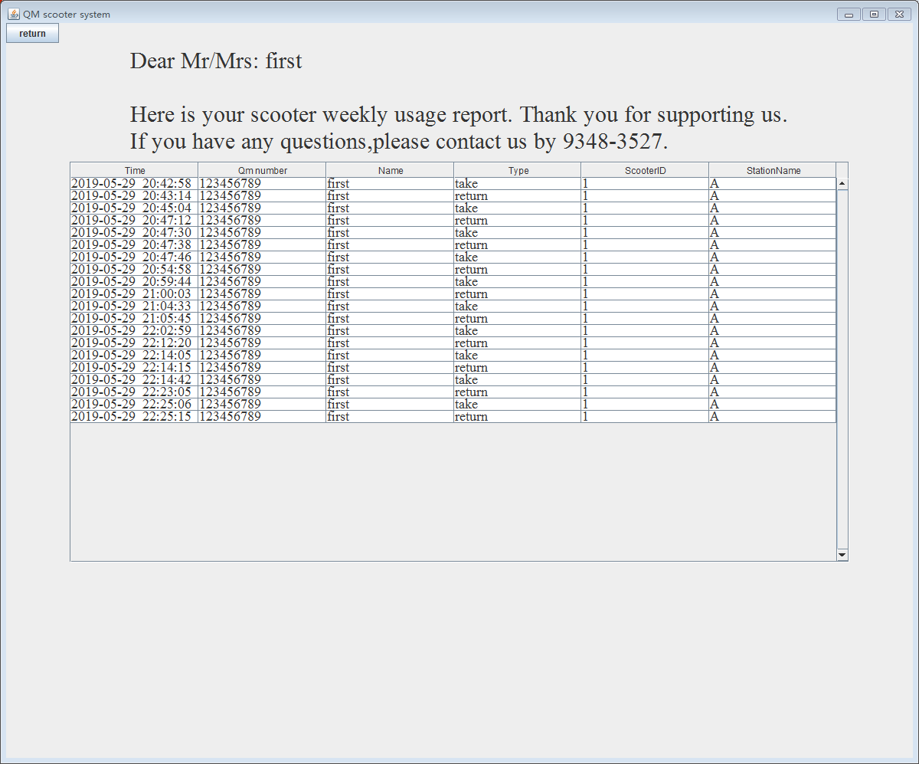
Figure B.12

That’s all for our system, thanks for your reading.
Hope you enjoy using it and have a nice day!

